3.71: a) The height above the player’s hand will be 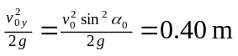, so the maximum height above the floor is 2.23 m. b) Use of the result of Problem 3.59 gives 3.84 m. c) The algebra is the same as that for Problems 3.58 and 3.62. The distance y is 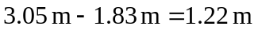, and
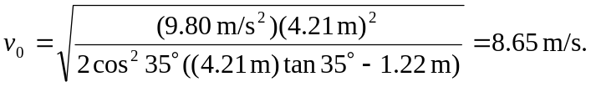
d) As in part (a), but with the larger speed,
The distance from the basket is the distance from the foul line to the basket, minus half the range, or
Note that an extra figure in the intermediate calculation was kept to avoid roundoff error.

